#include<stdio.h>

#include<conio.h>

#include<math.h>

int main()

{

int a,b,option;

clrscr();

printf("\n1. k\n2. x^n\n3. 1/x\n4. 1/(ax+b)\n5. e^(mx)\n6. a^x ");

printf("\n7. sin(ax)\n8. cos(ax)\n9. tan(ax)\n10. sec(ax)\n11. cosec(ax)\n12. cot(ax)");

printf("\n13. (secax)^2\n14. (cosecax)^2\n15. cosec(ax)cot(ax)\n16. sec(ax)tan(ax)");

printf("\n\nChoose function to integrate\n");

scanf("%d",&option);

clrscr();

switch(option)

{

case 1:

printf("\nf(x)=k\nF(x)=kx+c");

printf("\n\nEnter the value of k\n");

scanf("%d",&a);

if(a==0)

{

printf("\nf(x)=0\nF(x)=0");

}

else

{

printf("\nf(x)=%d",a);

printf("\nF(x)=%dx+c",a);

}

break;

case 2:

printf("\nf(x)=x^n\nF(x)=(x^n)/n+c");

printf("\n\nEnter the value of n\n");

scanf("%d",&a);

if(a==-2)

{

printf("\nf(x)=x^-2");

printf("\nF(x)=(-1/x)+c");

}

else if(a==-1)

{

printf("\nf(x)=1/x");

printf("\nF(x)=logx+c");

}

else if(a==0)

{

printf("\nf(x)=1");

printf("\nF(x)=x+c");

}

else

{

printf("\nf(x)=x^%d",a);

printf("\nF(x)=[(x^%d)/(%d)]+c",a+1,a+1);

}

break;

case 3:

printf("\nf(x)=1/x\nF(x)=logx+c");

break;

case 4:

printf("\nf(x)=1/(ax+b)\nF(x)=[(1/a)log(ax+b)]+c");

printf("\n\nEnter the values of a & b\n");

scanf("%d%d",&a,&b);

if(a==0&&b==0)

{

printf("Denominator cannot be zero\n");

}

else if(a==-1)

{

printf("\nf(x)=1/(-x+%d)",b);

printf("\nF(x)=-log(%d-x)+c",b);

}

else if(a==0&&b==1)

{

printf("\nf(x)=1");

printf("\nF(x)=x+c");

}

else if(a==0&&b==-1)

{

printf("\nf(x)=-1");

printf("\nF(x)=-x+c");

}

else if(a==1)

{

printf("\nf(x)=1/(x+%d)",b);

printf("\nF(x)=[log(x+%d)]+c",b);

}

else if(a==0)

{

printf("\nf(x)=1/%d",b);

printf("\nF(x)=(x/%d)+c",b);

}

else if(b==0)

{

printf("\nf(x)=1/(%dx)",a);

printf("\nF(x)=[(1/%d)log(%dx)]+c",a,a);

}

else

{

printf("\nf(x)=1/(%dx+%d)",a,b);

printf("\nF(x)=[(1/%d)log(%dx+%d)]+c",a,a,b);

}

break;

case 5:

printf("\nf(x)=e^(mx)\nF(x)=[e^(mx)/m]+c");

printf("\n\nEnter the value of m\n");

scanf("%d",&a);

if(a==0)

{

printf("\nf(x)=1");

printf("\nF(x)=x+c");

}

else if(a==-1)

{

printf("\nf(x)=e^(-x)");

printf("\nF(x)=[-e^(-x)]+c");

}

else if(a==1)

{

printf("\nf(x)=e^x");

printf("\nF(x)=(e^x)+c");

}

else

{

printf("\nf(x)=e^(%dx)",a);

printf("\nF(x)=[e^(%dx)/(%d)]+c",a,a);

}

break;

case 6:

printf("\nf(x)=a^x\nF(x)=[(a^x)/(loga)]+c");

printf("\n\nEnter the value of a\n");

scanf("%d",&a);

if(a==0)

{

printf("\nf(x)=0");

printf("\nF(x)=0");

}

else if(a==1)

{

printf("\nf(x)=1^x");

printf("\nF(x)=x+c where x is a real number");

}

else if(a<0)

{

printf("a cannot be negative\n");

}

else

{

printf("\nf(x)=%d^x",a);

printf("\nF(x)=[(%d^x)/(log%d)]+c",a,a);

}

break;

case 7:

printf("\nf(x)=sin(ax)\nF(x)=[-cos(ax)/a]+c");

printf("\n\nEnter the value of a\n");

scanf("%d",&a);

if(a==0)

{

printf("\nf(x)=0");

printf("\nF(x)=0");

}

else if(a==-1)

{

printf("\nf(x)=sin(-x)");

printf("\nF(x)=cosx+c");

}

else if(a<0)

{

printf("\nf(x)=sin(%dx)",a);

printf("\nF(x)=[cos(%dx)/%d]+c",abs(a),abs(a));

}

else if(a==1)

{

printf("\nf(x)=sinx");

printf("\nF(x)=-cosx+c");

}

else

{

printf("\nf(x)=sin(%dx)",a);

printf("\nF(x)=[-cos(%dx)/%d]+c",a,a);

}

break;

case 8:

printf("\nf(x)=cos(ax)\nF(x)=[sin(ax)/a]+c");

printf("\n\nEnter the value of a\n");

scanf("%d",&a);

if(a==0)

{

printf("\nf(x)=1");

printf("\nF(x)=x+c");

}

else if(a==1)

{

printf("\nf(x)=cosx");

printf("\nF(x)=sinx+c");

}

else if(a==-1)

{

printf("\nf(x)=cos(-x)");

printf("\nF(x)=sinx+c");

}

else if(a<0)

{

printf("\nf(x)=cos(%dx)",a);

printf("\nF(x)=[sin(%dx)/%d]+c",abs(a),abs(a));

}

else

{

printf("\nf(x)=cos(%dx)",a);

printf("\nF(x)=[sin(%dx)/%d]+c",a,a);

}

break;

case 9:

printf("\nf(x)=tan(ax)");

printf("\nF(x)=[log(secax)/a]+c");

printf("\n =[(-log(cosax)/a]+c");

printf("\n\nEnter the value of a\n");

scanf("%d",&a);

if(a==0)

{

printf("\nf(x)=0");

printf("\nF(x)=0");

}

else if(a==1)

{

printf("\nf(x)=tanx");

printf("\nF(x)=log(secx)+c");

printf("\n =-log(cosx)+c");

}

else if(a==-1)

{

printf("\nf(x)=tan(-x)");

printf("\nF(x)=-log(secx)+c");

printf("\n =log(cosx)+c");

}

else if(a<0)

{

printf("\nf(x)=tan(%dx)",a);

printf("\nF(x)=[-log(sec%dx)/%d]+c",abs(a),abs(a));

printf("\n =[log(cos%dx)/%d]+c",abs(a),abs(a));

}

else

{

printf("\nf(x)=tan(%dx)",a);

printf("\nF(x)=[log(sec%dx)/%d]+c",a,a);

printf("\n =[-log(cos%dx)/%d]+c",a,a);

}

break;

case 10:

printf("\nf(x)=sec(ax)");

printf("\nF(x)=[log(secax+tanax)/a]+c");

printf("\n\nEnter the value of a\n");

scanf("%d",&a);

if(a==0)

{

printf("\nf(x)=1");

printf("\nF(x)=x+c");

}

else if(a==1)

{

printf("\nf(x)=secx");

printf("\nF(x)=[log(secx+tanx)]+c");

}

else if(a==-1)

{

printf("\nf(x)=sec(-x)");

printf("\nF(x)=[log(secx+tanx)]+c");

}

else if(a<0)

{

printf("\nf(x)=sec(%dx)",a);

printf("\nF(x)={[log(sec%dx+tan%dx)]/%d}+c",abs(a),abs(a),abs(a));

}

else

{

printf("\nf(x)=sec(%dx)",a);

printf("\nF(x)={[log(sec%dx+tan%dx)]/%d}+c",a,a,a);

}

break;

case 11:

printf("\nf(x)=cosec(ax)");

printf("\nF(x)=[log(cosecax-cotax)/a]+c");

printf("\n\nEnter the value of a\n");

scanf("%d",&a);

if(a==0)

{

printf("\nf(x)=0");

printf("\nF(x)=0");

}

else if(a==1)

{

printf("\nf(x)=cosecx");

printf("\nF(x)=[log(cosecx-cotx)]+c");

}

else if(a==-1)

{

printf("\nf(x)=cosec(-x)");

printf("\nF(x)=[-log(cosec(-x)-cot(-x))]+c");

}

else if(a>0)

{

printf("\nf(x)=cosec(%dx)",a);

printf("\nF(x)=[log(cosec%dx-cot%dx)/%d]+c",a,a,a);

}

else

{

printf("\nf(x)=cosec(%dx)",a);

printf("\nF(x)=[-log(cosec(%dx)-cot(%dx))/%d]+c",a,a,abs(a));

}

break;

case 12:

printf("\nf(x)=cot(ax)");

printf("\nF(x)=[log(sinax)/a]+c");

printf("\n\nEnter the value of a\n");

scanf("%d",&a);

if(a==0)

{

printf("\nf(x)=0");

printf("\nF(x)=0");

}

else if(a==1)

{

printf("\nf(x)=cotx");

printf("\nF(x)=log(sinx)+c");

}

else if(a==-1)

{

printf("\nf(x)=cot(-x)");

printf("\nF(x)=-log(sin(-x))+c");

}

else if(a<0)

{

printf("\nf(x)=cot(%dx)",a);

printf("\nF(x)=[-log(sin(%dx))/%d]+c",a,abs(a));

}

else

{

printf("\nf(x)=cot(%dx)",a);

printf("\nF(x)=[log(sin(%dx))/%d]+c",a,a);

}

break;

case 13:

printf("\nf(x)=(secax)^2");

printf("\nF(x)=[tan(ax)/a]+c");

printf("\n\nEnter the value of a\n");

scanf("%d",&a);

if(a==0)

{

printf("\nf(x)=1");

printf("\nF(x)=x+c");

}

else if(a==1)

{

printf("\nf(x)=(secx)^2");

printf("\nF(x)=tanx+c");

}

else if(a==-1)

{

printf("\nf(x)=(sec(-x))^2");

printf("\nF(x)=-tan(-x)+c");

}

else if(a<0)

{

printf("\nf(x)=(sec(%dx))^2",a);

printf("\nF(x)=[-tan(%dx)/%d]+c",a,abs(a));

}

else

{

printf("\nf(x)=(sec(%dx))^2",a);

printf("\nF(x)=[tan(%dx)/%d]+c",a,a);

}

break;

case 14:

printf("\nf(x)=(cosecax)^2");

printf("\nF(x)=[(-cotax)/a]+c");

printf("\n\nEnter the value of a\n");

scanf("%d",&a);

if(a==0)

{

printf("\nf(x)=0");

printf("\nF(x)=0");

}

else if(a==1)

{

printf("\nf(x)=(cosecx)^2");

printf("\nF(x)=-cotx+c");

}

else if(a==-1)

{

printf("\nf(x)=(cosec(-x))^2");

printf("\nF(x)=cot(-x)+c");

}

else if(a<0)

{

printf("\nf(x)=(cosec(%dx))^2",a);

printf("\nF(x)=[cot(%dx)/%d]+c",a,abs(a));

}

else

{

printf("\nf(x)=(cosec(%dx))^2",a);

printf("\nF(x)=[-cot(%dx)/%d]+c",a,a);

}

break;

case 15:

printf("\nf(x)=cosec(ax)cot(ax)");

printf("\nF(x)=[-cosec(ax)/a]+c");

printf("\n\nEnter the value of a\n");

scanf("%d",&a);

if(a==0)

{

printf("\nf(x)=0");

printf("\nF(x)=0");

}

else if(a==1)

{

printf("\nf(x)=cosecxcotx");

printf("\nF(x)=-cosecx+c");

}

else if(a==-1)

{

printf("\nf(x)=cosec(-x)cot(-x)");

printf("\nF(x)=cosec(-x)+c");

}

else if(a<0)

{

printf("\nf(x)=cosec(%dx)cot(%dx)",a,a);

printf("\nF(x)=[cosec(%dx)/%d]+c",a,abs(a));

}

else

{

printf("\nf(x)=cosec(%dx)cot(%dx)",a,a);

printf("\nF(x)=[-cosec(%dx)/%d]+c",a,a);

}

break;

case 16:

printf("\nf(x)=sec(ax)tan(ax)");

printf("\nF(x)=[sec(ax)/a]+c");

printf("\n\nEnter the value of a\n");

scanf("%d",&a);

if(a==0)

{

printf("\nf(x)=0");

printf("\nF(x)=0");

}

else if(a==1)

{

printf("\nf(x)=secxtanx");

printf("\nF(x)=secx+c");

}

else if(a==-1)

{

printf("\nf(x)=sec(-x)tan(-x)");

printf("\nF(x)=-sec(-x)+c");

}

else if(a<0)

{

printf("\nf(x)=sec(%dx)tan(%dx)",a,a);

printf("\nF(x)=[-sec(%dx)/%d]+c",a,abs(a));

}

else

{

printf("\nf(x)=sec(%dx)tan(%dx)",a,a);

printf("\nF(x)=[sec(%dx)/%d]+c",a,a);

}

break;

default:

printf("\nWrong input\n");

}

getch();

return 0;

}

**OUTPUTS:**

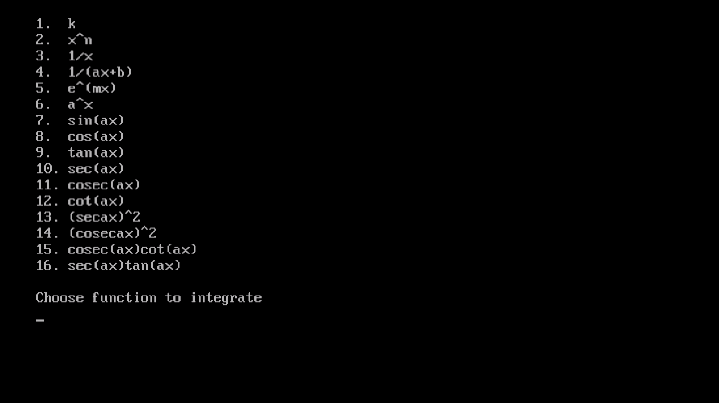

**FUNCTIONS THAT CAN BE INTEGRATED**

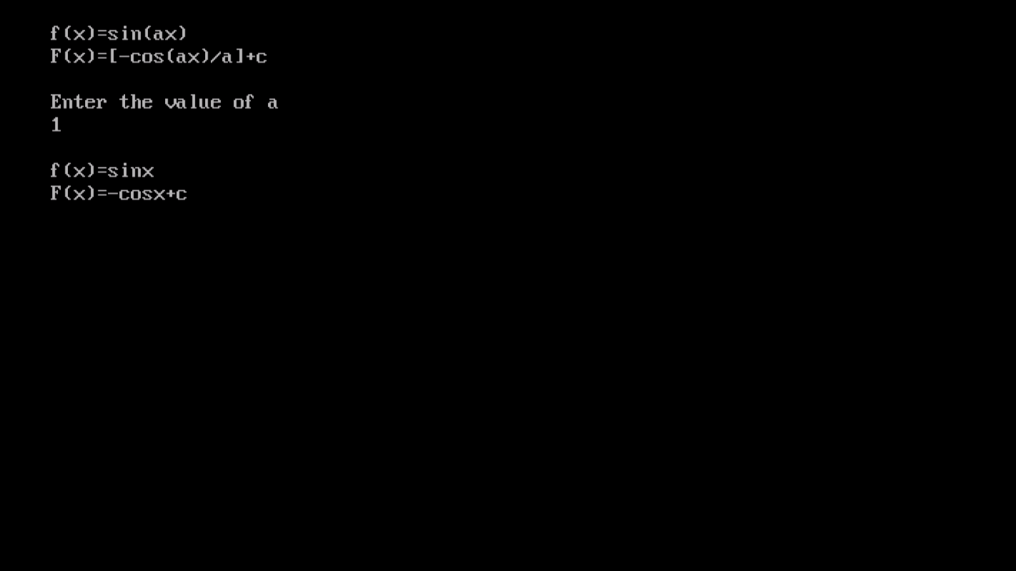

$$f\left(x\right)=\sin{ax}, F\left(x\right)=-\frac{\cos{ax}}{a}+c$$

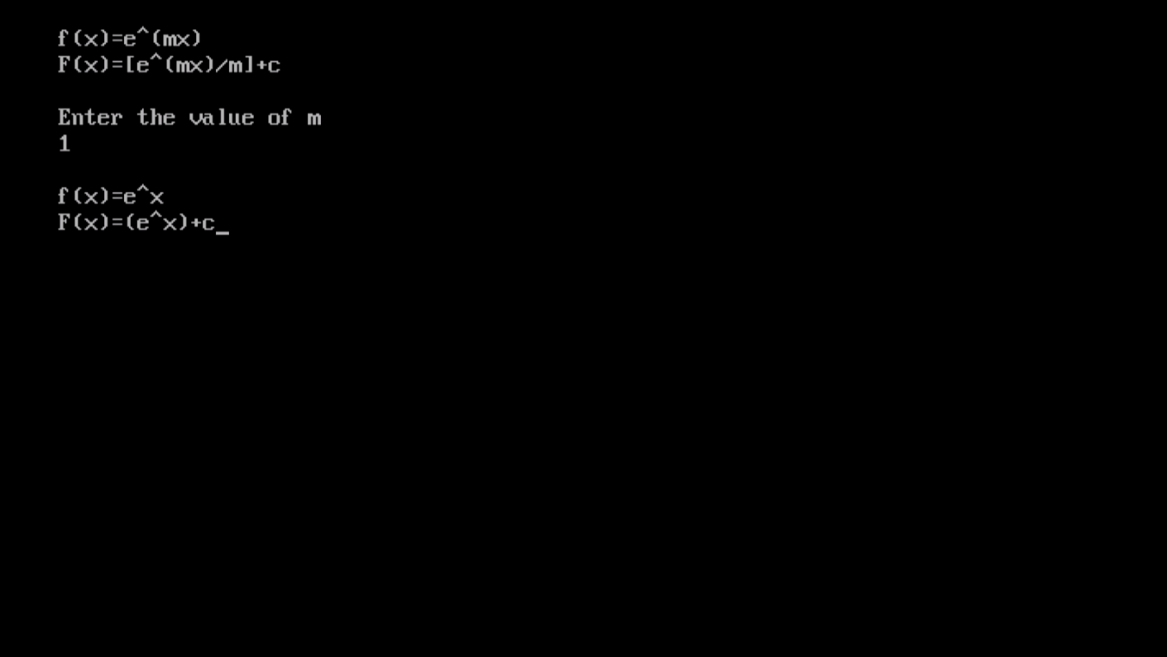

$$f\left(x\right)=e^{mx}, F\left(x\right)=\frac{e^{mx}}{m}+c$$